**Jai Swaminarayan**

Title: realtime object measurement from distance using OpenCv and LiDAR

Keywords: LiDAR Sensor, OpenCv Object Detection, Height and Width of Object from distance, realtime object measurement

Abstract:

Nowadays autonomous technology has gained so much popularity as robots are heavily dependent upon various sensors and cameras. It requires too much automation to run robots. And there is a challenge to measure an object’s position, height and width. We figured it out how to measure the distance of and object using LiDAR sensor and its height and width with using OpenCv.

Terms:

1. LiDAR: LiDAR stands for Light Detection and Ranging sensor, it is used to measure the distance between sensor and object.
2. OpenCv: OpenCv is an open-source library for Computer vision and Machine Learning.
3. Distance: the distance between object and camera

Introduction:

Since our WaterFly team is working on making autonomous drone project, we got the challenge to detect the object in advance so the drone can decide to go left/ right/ up/ down/ straight/ back. To know in advance we use LiDAR sensor so we get the distance, and for object detection, we have used OpenCv to detect the object. To measure the height and width of the object we calculated the per pixel centimetre.

Following are the steps to find the solution:

1. First, we need to fix the camera and sensor in the same position
2. Click the photos and record respective object’s height, width and distance between object and camera.
3. For prediction we need to use simple linear regression algorithm of Machine learning, will prepare dataset by performing step 2 for 30 to 40 times
4. record data in CSV format and find out per pixel centimetre by following steps:
5. convert the whole image into centimetre as we know the object’s height and width in cm:
   1. image’s height in cm:

if object’s height is a pixel when object’s height is b cm,

then what will be the full image’s height in cm when c pixels is the height of an image

full images’s height in cm = (c * b) / a

= (image’s height in pixel * object’s height in cm) / object’s height in pixel

* 1. image’s width in cm:

full images’s height in cm = (image’s width in pixel * object’s width in cm) / object’s width in pixel

1. record data in CSV formate and find out per pixel centimetre by following steps:
2. convert the whole image into centimetre as we know the object’s height
3. now convert the image’s height and width in per pixel centimetre (cm)
   1. 1 pixel of height = full image’s height in cm/ full image’s height in pixel
   2. 1 pixel of width = full image’s width in cm/ full image’s width in pixel
4. we need two simple linear regression model one for height and another for width
   1. For Hight:
      * independent variable’s value(x) is the distance in centimetre and the dependent variable’s value is the object’s height in per pixel centimetre
   2. For width:
      * independent variable’s value(x) is the distance in centimetre and the dependent variable’s value is the object’s width in per pixel centimetre
5. Dataset will look like this:

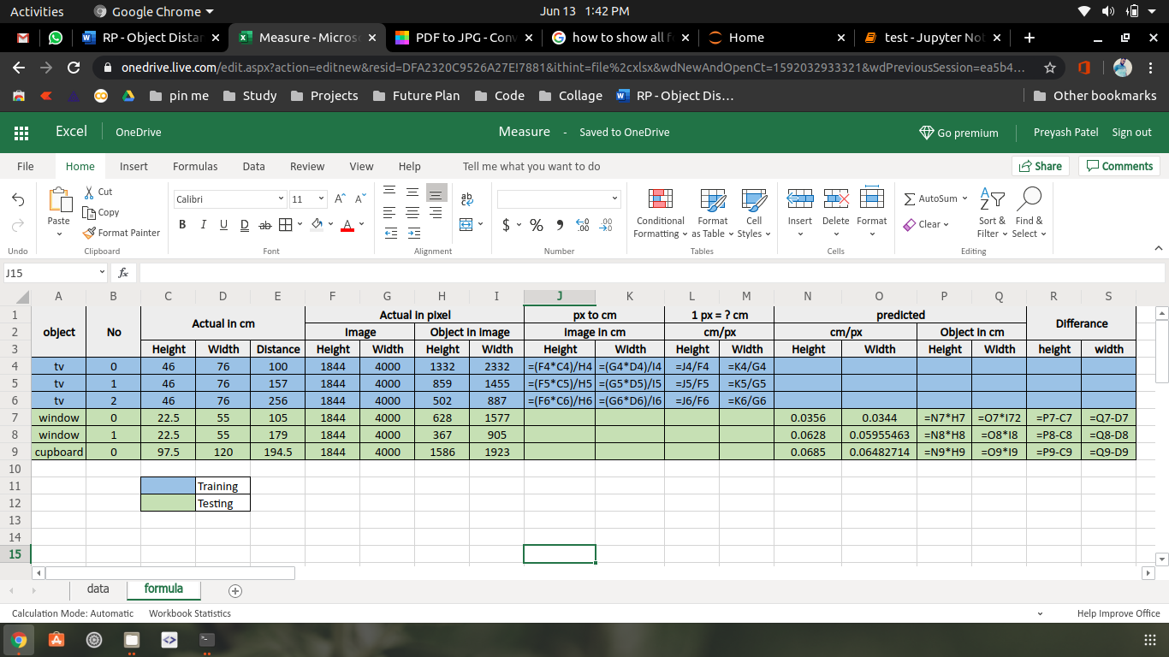

Values:

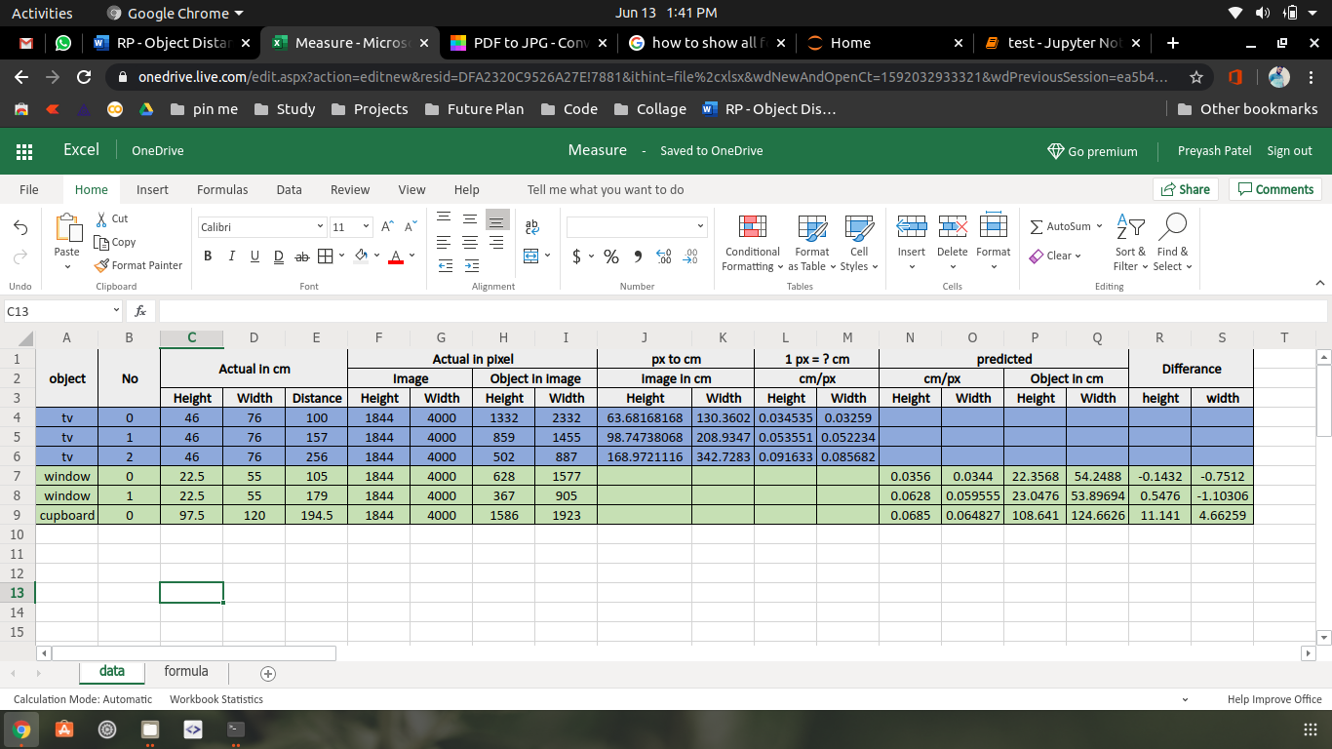

Formulas:

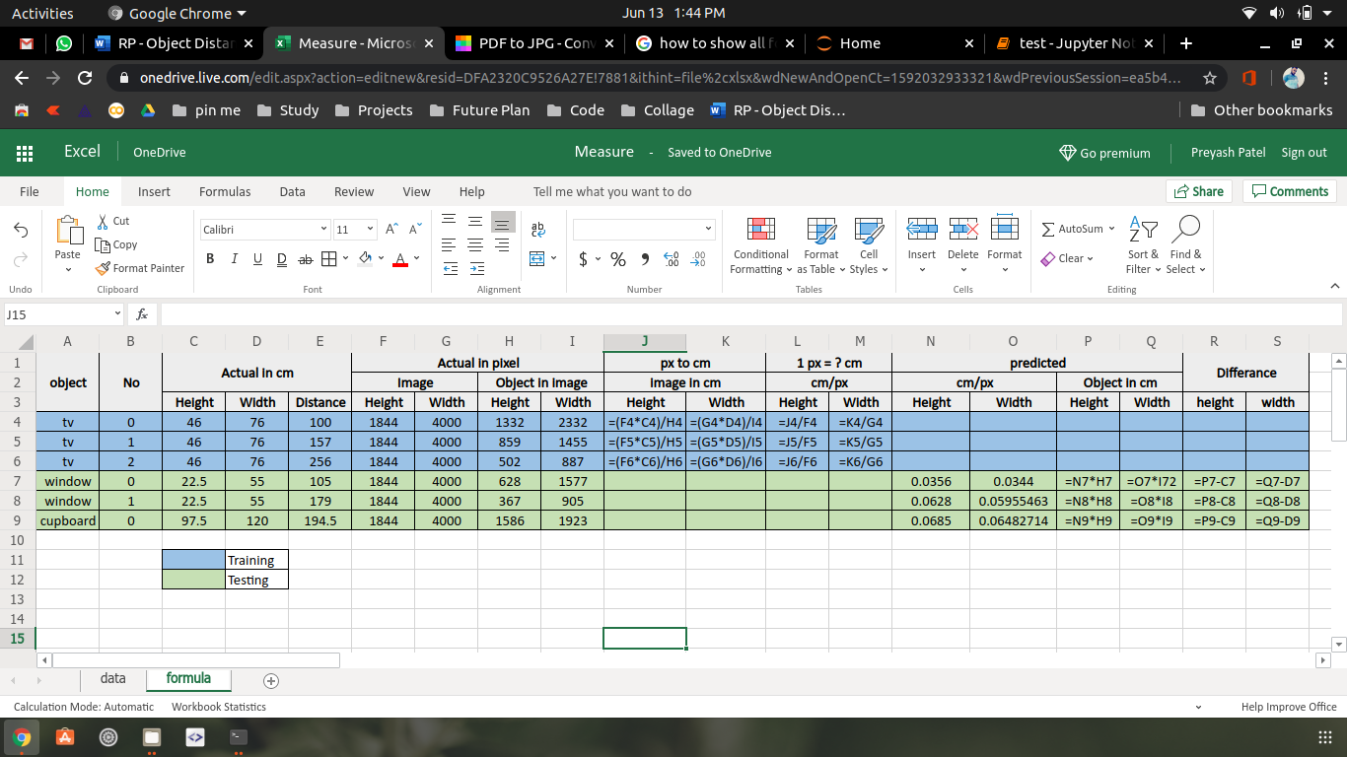

1. Validate the model to measure the accuracy and then implement
2. In realtime camera and object’s distance will be provided by LiDAR sensor
3. OpenCV's object detection algorithm will provide the height and width of an object in pixel
4. then the model will provide per pixel centimetre based on object and camera’s distance, so simply multiply the object’s height and width with respective per pixel centimetre
5. And we got the object’s height and width in centimetre

Limitations:

1. Accuracy of measuring distance from LiDAR differ from different type’s LiDAR sensor
2. Changing the camera requires the respective camera's dataset to train the model
3. Providing insufficient data for model training

Conclusion:

With the help of OpenCv, we can capture a live image of an object and it’s measurements in pixel, object and camera’s distance is measured by LiDAR sensor, this three-variable will produce realtime object’s measurement in centimetre.

Acknowledgement:

????

References:

1. <https://opencv.org/>
2. ????